LAB 1 SUBIMISSION

Task 1:
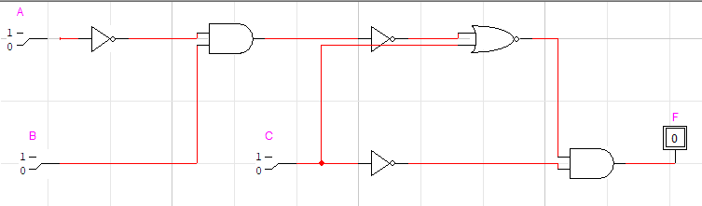
A | B | C | F=$\overline{A}.B.\overline{C}$
0 | 0 | 0 | 0
0 | 0 | 1 | 0
0 | 1 | 0 | 1
0 | 1 | 1 | 0
1 | 0 | 0 | 0
1 | 0 | 1 | 0
1 | 1 | 0 | 0
1 | 1 | 1 | 0

Task 2:
1.
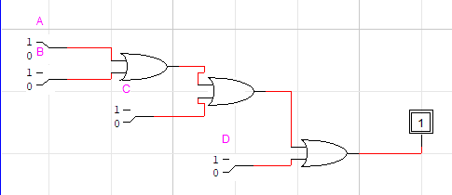

2.
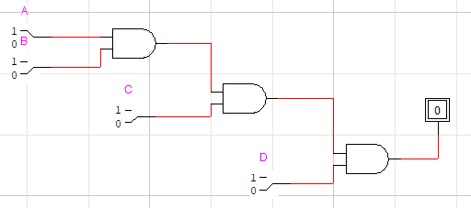
3.
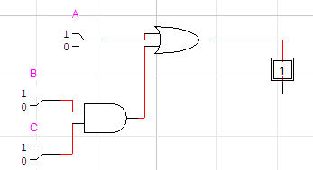
4.
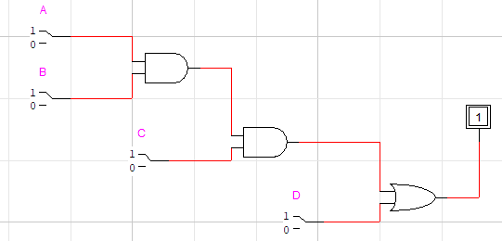

Task 3:
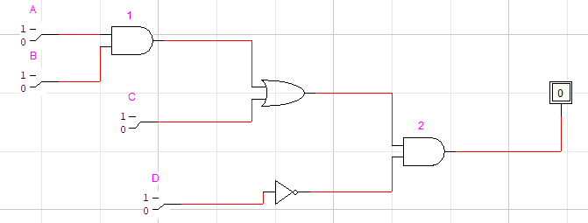
A | B | C | D | (A. B) | ((A.B)+C) | $$\overline{D}$$ | Y=((A.B)+C$\overline{D}$)
0 | 0 | 0 | 0 | 0 | 0 | 1 | 0
0 | 0 | 0 | 1 | 0 | 0 | 0 | 0
0 | 0 | 1 | 0 | 0 | 1 | 1 | 1
0 | 0 | 1 | 1 | 0 | 1 | 0 | 0
0 | 1 | 0 | 0 | 0 | 0 | 1 | 0
0 | 1 | 0 | 1 | 0 | 0 | 0 | 0
0 | 1 | 1 | 0 | 0 | 1 | 1 | 1
0 | 1 | 1 | 1 | 0 | 1 | 0 | 0
1 | 0 | 0 | 0 | 0 | 0 | 1 | 0
1 | 0 | 0 | 1 | 0 | 0 | 0 | 0
1 | 0 | 1 | 0 | 0 | 1 | 1 | 1
1 | 0 | 1 | 1 | 0 | 1 | 0 | 0
1 | 1 | 0 | 0 | 1 | 1 | 1 | 1
1 | 1 | 0 | 1 | 1 | 1 | 0 | 0
1 | 1 | 1 | 0 | 1 | 1 | 1 | 1
1 | 1 | 1 | 1 | 1 | 1 | 0 | 0

Task 4:
